PhD position in climate and health modelling

The research group of „Hydrological and climate variability“ at the Faculty of Environmental Sciences (FES), the Czech University of Life Science in Prague, announces an opening for a PhD position in modelling of relationships between climate and human health. The PhD position is embedded in the new GAČR project led by Dr. Aleš Urban (researcher ID: H-6476-2014). The aim of the proposed project is to assess historical connections between weather variability, seasonal patterns of mortality, and the occurrence of acute respiratory infections in temperate climate conditions.

The title of the PhD project is: The role of acute respiratory infections in the relationships between climate variability and mortality
The aim of the PhD project will be to clarify associations between climate variability ​​and seasonal patterns of mortality in the Czech Republic using modern methods of time series analysis. Special focus will be given on the analysis of seasonal patterns of respiratory infectious diseases, how these patterns are associated with climate variability, and how they affect the general seasonal patterns in mortality.
The candidate should have an M.Sc. degree in Environmental Science, Environmental Modelling, Environmental Epidemiology, Climate Science, or related field. We expect the candidate will be self-motivated and interested in the research topic. Good knowledge in statistics, scientific programming and data analysis, and experience in working with tools for the analysis and visualisation of time series data (e.g. R/RStudio, Matlab, or similar) are expected. Additional skills will be gained and improved during the PhD project. The successful candidate will participate in the GAČR project, will contribute to preparation and submission of research grants, and is expected to participate in these grants.
For further information send your CV and motivation letter to Dr. Aleš Urban (urbana@fzp.czu.cz) until January 31, 2022.
The position is limited to 4 years. In case of good results, a follow-up postdoc researcher position may be possible.
The candidate will receive a monthly net scholarship 350-500 EUR (with annual increase based on performance), additional salary from the GAČR project up to 700 EUR, and publication rewards. The successful candidate is expected to participate in relevant projects submitted at the Faculty of Environmental Sciences (FES) and the Institute of Atmospheric Physics of the Czech Academy of Sciences.
The place of employment will be Prague. The targeted starting date of the PhD position is 1st
October 2022 but earlier start of the collaboration (e.g. on online basis) is beneficial. Most of the foreign PhD candidates get place at campus dormitories.
As a PhD student at the Faculty of Environmental Sciences, the Czech University of Life Sciences, the candidate is expected to publish results in international peer-reviewed journals, to participate at international conferences, etc.
Additional information about the admission procedure is available here: https://www.fzp.czu.cz/en/r-9409-science-research/r-9533-doctoral-study/r-9800-admission-procedure
Additional information about the PhD programme is available here:
https://www.fzp.czu.cz/en/r-9409-science-research/r-9533-doctoral-study/r-9802-ph-d-programmes/r-15360-environmental-earth-sciences/r-15361-specializations/r-15362-environmental-modelling#i-4c204cbf00fda6fac24fa9749ba9ca08

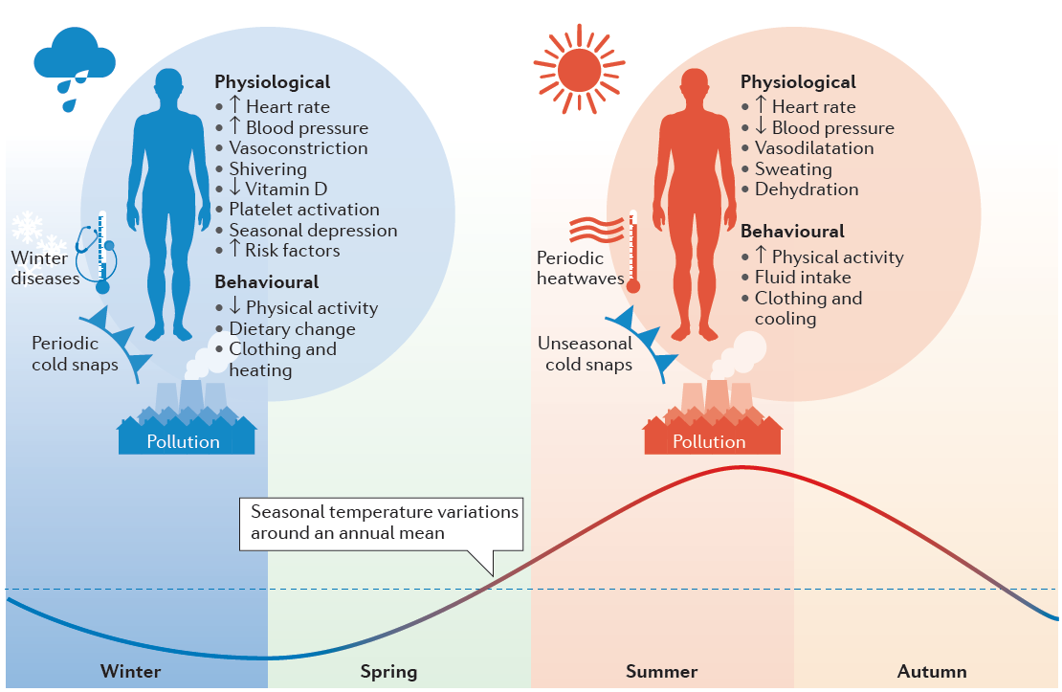
References:
Kinney PL, Schwartz J, Pascal M, et al (2012) Winter season mortality: will climate warming bring benefits? Environ Res Lett 10:64016. doi: 10.1088/1748-9326/10/6/064016
Stewart S, Keates AK, Redfern A, McMurray JJ V. (2017) Seasonal variations in cardiovascular disease. Nat Rev Cardiol 9:1–13. doi: 10.1038/nrcardio.2017.76

